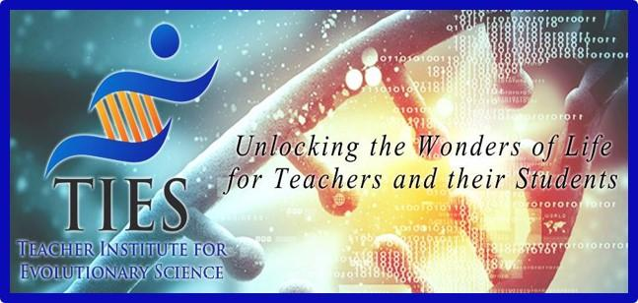

TIES Station Rotation
Lesson Plan

Grade Level: 6-8

Lesson Length: 50 minutes x 2.5 (2.5-3 classes)

Lesson Topic: Natural Selection and Adaptation.

Standards Addressed: Natural Selection and Adaptation

A. The scientific theory of evolution is the organizing principle of life science.
B. The scientific theory of evolution is supported by multiple forms of evidence.
C. Natural Selection is a primary mechanism leading to change over time in organisms.

Student Outcome(s):
- Cite specific textual evidence to support analysis of science and technical texts, attending to the precise details of explanations or descriptions.
- Integrate quantitative or technical information expressed in words in a text with a version of that information expressed visually (e.g., in a flowchart, diagram, model, graph, or table).
- Analyze and interpret data for patterns in the fossil record that document the existence, diversity, extinction, and change of life forms throughout the history of life on Earth under the assumption that natural laws operate today as in the past.
- Apply scientific ideas to construct an explanation for the anatomical similarities and differences among modern organisms and between modern and fossil organisms to infer evolutionary relationships.

Materials:
- Slides 2-8 should be laminated and placed at stations throughout the classroom.
- Each student should receive slides 9-16 to serve as their worksheets.
- Rubbing fossil plate
- 1-2 laptops with Ted-Ed videos loaded

Activities/Tasks
What learning opportunities will your students engage in?

Opening Activities:
Station 1: Vestigial structures vs homologous structures
Station 2: 11 strips of animal DNA placed in an envelope
Station 3: Law of Superposition, 4 reference pages
Station 4: Fossil rub palate
Station 5: Watch TED ED Why are Sloths So Slow
Station 6: Watch TED ED Carnivorous Plants

Procedures:
Set a large 15 minute timer for all students to see. Instruct them that they will be moving throughout 6 stations as small groups, collecting evidence for evolution. If done early, they are to stay at their current station, read the directions for the next station or if they need to, finish a previous station’s assignment.

Wrap-Up:
Once students have completed all stations, teacher/students will review answers and have a discussion.

Assessment/Evaluation:
Each student will have a collection of data, drawings, notes and short answers from visiting the stations. These are to be handed in and graded on completion and accuracy.

