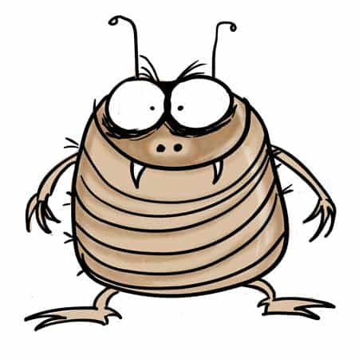
Bell-ringer Activity
Those Pesky Fleas!
We recommend teachers cover genetics before evolution. If this is possible, show the students a photo of any brand of flea medication found in US pet stores.
For example, the medication shown here:

Create a personal story about something you or a friend may have experienced about the inefficacy of flea medicine,
For example,
“My dog Jinx got fleas. I purchased flea medication at my local pet store. Flea medicine is expensive! It cost me $78 for a three-month supply. Well, Jinx still had fleas even after I applied it to her neck. I took her to the vet and my vet said, ‘Oh yeah, those meds do not work anymore.’”
Now ask the students to tell you why these medications are rendered ineffective over time.
This can be done on paper individually or in small groups.
Sample answer:
Some fleas were lucky enough to receive a random mutation which made them resistant to the medicine. Over time, the sensitive fleas died and the resistant fleas spread in the population.
At this point, say, “Ok, we just covered evolution, let’s move on to ecology!” After a few seconds of disbelief and/or laughter. Explain that natural selection, one of the primary mechanisms for evolution, happens when there is variation in a population (resistance vs sensitivity to flea medication, for example). The variations are caused by random genetic mutations. Sometimes, these random genetic mutations can be beneficial for the survival of certain individuals in the population. If this mutation is heritable (passed on to the offspring) the population can change over time as more offspring are born with the beneficial mutation.


Figure 1 For more resources, visit us at www.tieseducation.org

