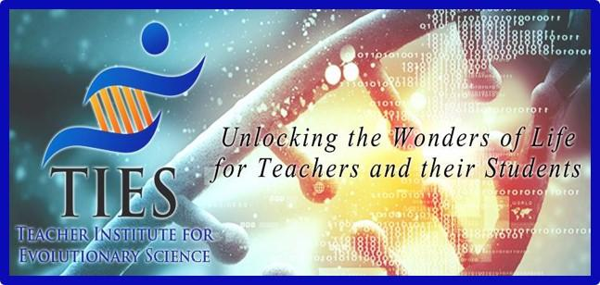

Moth Simulation Lab

Connecting to the Next Generation Science Standards

- The chart below makes one set of connections between the instructions outlined on our website www.tieseducation.org and the NGSS. Other valid connections are likely.
- The materials, lessons, and activities outlined on our TIES website are just one step toward reaching the performance expectation listed below.

Standard
MS-LS4 Natural Selection and Adaptation

Performance Expectation
MS-LS4-6. | Use mathematical representations to support explanations of how natural selection may lead to increases and decreases of specific traits in populations over time

Dimensions | Classroom Connections
Science and Engineering Practice
Using Mathematics and Computational Thinking | Use mathematical representations to support scientific conclusions and design solutions.
Disciplinary Core Idea
LS4.B: Natural Selection | Natural selection leads to the predominance of certain traits in a population, and the suppression of others.
Crosscutting Concepts
Patterns | Patterns can be used to identify cause and effect relationships.
Cause and Effect | Phenomena may have more than one cause, and some cause and effect relationships in systems can only be described using probability.

Connections to the Common Core State Standards
SL.8.1 Engage effectively in a range of collaborative discussions (one-on-one, in groups, teacher-led) with diverse partners on grade 6 topics, texts, and issues, building on others’ ideas and expressing their own clearly.
SL.8.4 Present claims and findings, emphasizing salient points in a focused, coherent manner with relevant evidence, sound valid reasoning, and well-chosen details; use appropriate eye contact, adequate volume, and clear pronunciation.
6.SP.B.5 Summarize numerical data sets in relation to their context.

