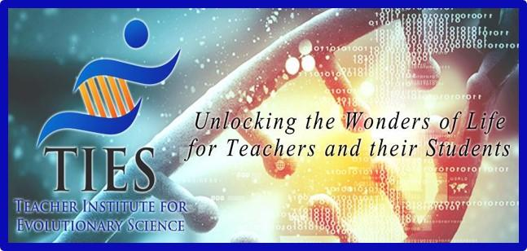

This Lab is for the Birds
Lesson Plan

Grade Level: 6-8

Lesson Length: 50 minutes (1 class)

Lesson Topic: Natural Selection and Adaptation. This lab activity helps students understand how natural selection, the driving force of evolution, acts on a population.

Standards Addressed: Natural Selection and Adaptation

A. The scientific theory of evolution is the organizing principle of life science.
B. The scientific theory of evolution is supported by multiple forms of evidence.
C. Natural Selection is a primary mechanism leading to change over time in organisms.

Student Outcome(s):
- Engage effectively in a range of collaborative discussions (one-on-one, in groups, teacher-led) with diverse partners on grade 6 topics, texts, and issues, building on others’ ideas and expressing their own clearly.
- Present claims and findings, emphasizing salient points in a focused, coherent manner with relevant evidence, sound valid reasoning, and well-chosen details; use appropriate eye contact, adequate volume, and clear pronunciation.
- Summarize numerical data sets in relation to their context.

Materials:
- 4 beak models, 1 of each model for each lab group: toothpicks, plastic forks, spoons, and knives
- Two large paper plates
- Two model food items: hard food items such as beans or M&Ms and soft food items such as raisins
- One paper cup (model mouth) for each student.
- Stopwatch

Activities/Tasks
What learning opportunities will your students engage in?

Opening Activities: There tends to be variation within a population. For example, some humans have blue eyes and others have brown or green eyes. Can you think of another variation within our own human species?
Utensil birds also exhibit variation in their species. Utensil birds have beaks that look like single toothpicks, spoons, forks, or knives. These are the 4 beak phenotypes in Aves utensilis. Phenotypes are the physical expressions of a gene in a population. Ask: Which beak type do you believe has the best features for collecting “food” and helping an individual bird survive in a changing environment?

Procedures:
1. Your group will receive a plate filled with a soft food item, raisins.
2. When the timer says “go,” each person will collect as many items as possible from
the plate that is placed in the center of your table. Collect one food item at a time!
3. After 10 seconds, the timer will say “stop” and all birds will put down their “beaks.”
4. Record the total number of items that each bird collected on the data log titled, “Food Items Collected by Each Beak Type: Soft Food Trials”.
5. Repeat steps 1-4 for a second and a third trial with the soft food items. “Mother Nature” (aka, your teacher) may need to add more food.
6. Calculate the mean number of soft food items collected by each bird.

Wrap-Up:
1. The first basic condition for natural selection to occur is that there must be variability within a species. What variability was present in the population of utensil birds?

2. Before the terrible drought, which beak types gathered the most food items?

3. After the terrible drought, which beak type was most successful?

4. Over time, if drought conditions continue, what will happen to the number of birds with the spoon beaks in the population? What will happen to the birds with the other beak types?

Assessment/Evaluation:
3 tables on the student worksheet will be completed and calculated. Wrap-up questions will be written down and graded on student worksheet.

5. As the individuals of the species change over time, the whole species may begin to look very different. It may even become a completely different species. What is the name of this process called?

