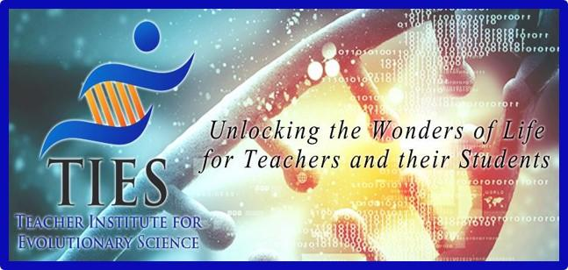

Ready-to-Go Unit MS
Lesson Plan

Grade Level: 6-8

Lesson Length: 50 minutes x 6 (5-6 classes)

Lesson Topic: Natural Selection and Adaptation

Standards Addressed:Biological Evolution: Unity and Diversity

A. The scientific theory of evolution is the organizing principle of life science.
B. The scientific theory of evolution is supported by multiple forms of evidence.
C. Natural Selection is a primary mechanism leading to change over time in organisms.

Student Outcome(s):
- Cite specific textual evidence to support analysis of science and technical texts, attending to the precise details of explanations or descriptions.
- Integrate quantitative or technical information expressed in words in a text with a version of that information expressed visually (e.g., in a flowchart, diagram, model, graph, or table).
- Analyze and interpret data for patterns in the fossil record that document the existence, diversity, extinction, and change of life forms throughout the history of life on Earth under the assumption that natural laws operate today as in the past.
- Apply scientific ideas to construct an explanation for the anatomical similarities and differences among modern organisms and between modern and fossil organisms to infer evolutionary relationships.
- Analyze displays of pictorial data to compare patterns of similarities in the embryological development across multiple species to identify relationships not evident in the fully formed anatomy.
- Construct an explanation based on evidence that describes how genetic variations of traits in a population increase some individuals’ probability of surviving and reproducing in a specific environment.

Materials:
- TIES MS Evolution PowerPoint
- Computers for students
- Lab supplies listed under individual labs/activities on https://tieseducation.org/teacher-materials/

Activities/Tasks
What learning opportunities will your students engage in?

Opening Activities:
- Teach/discuss 1-2 lessons per day on the PowerPoint.
- Each day choose one of the following opening activities:
  - #1 Face or Fiction
  - #2 Flea Evolution
  - Fossils Bellringer

Procedures:
As a class, read and discuss a few slides a day. Use the hyperlinks to have students watch or interact with various websites, videos and online assessments. These pop-out activities/digital lessons can be done individually, in partners/groups or as a class.

Teacher talking points are in the notes section of each slide.

Wrap-Up:
Once students have completed all lessons, teacher/students will review answers and have a discussion.

Assessment/Evaluation:
Each student will have a collection of notes and short answers from reading/watching all the lessons. These are to be handed in and graded on completion and accuracy. A TIES Unit multiple choice test is also available upon request: Evolution Exam | Teacher Institute for Evolutionary Science (tieseducation.org)

